DPJ

In Level 1, we installed the Input System through the Package Manager. Then, we created an Action Map dedicated to movement and we defined the directional keys (W, A, S, D) that we would use to control the character

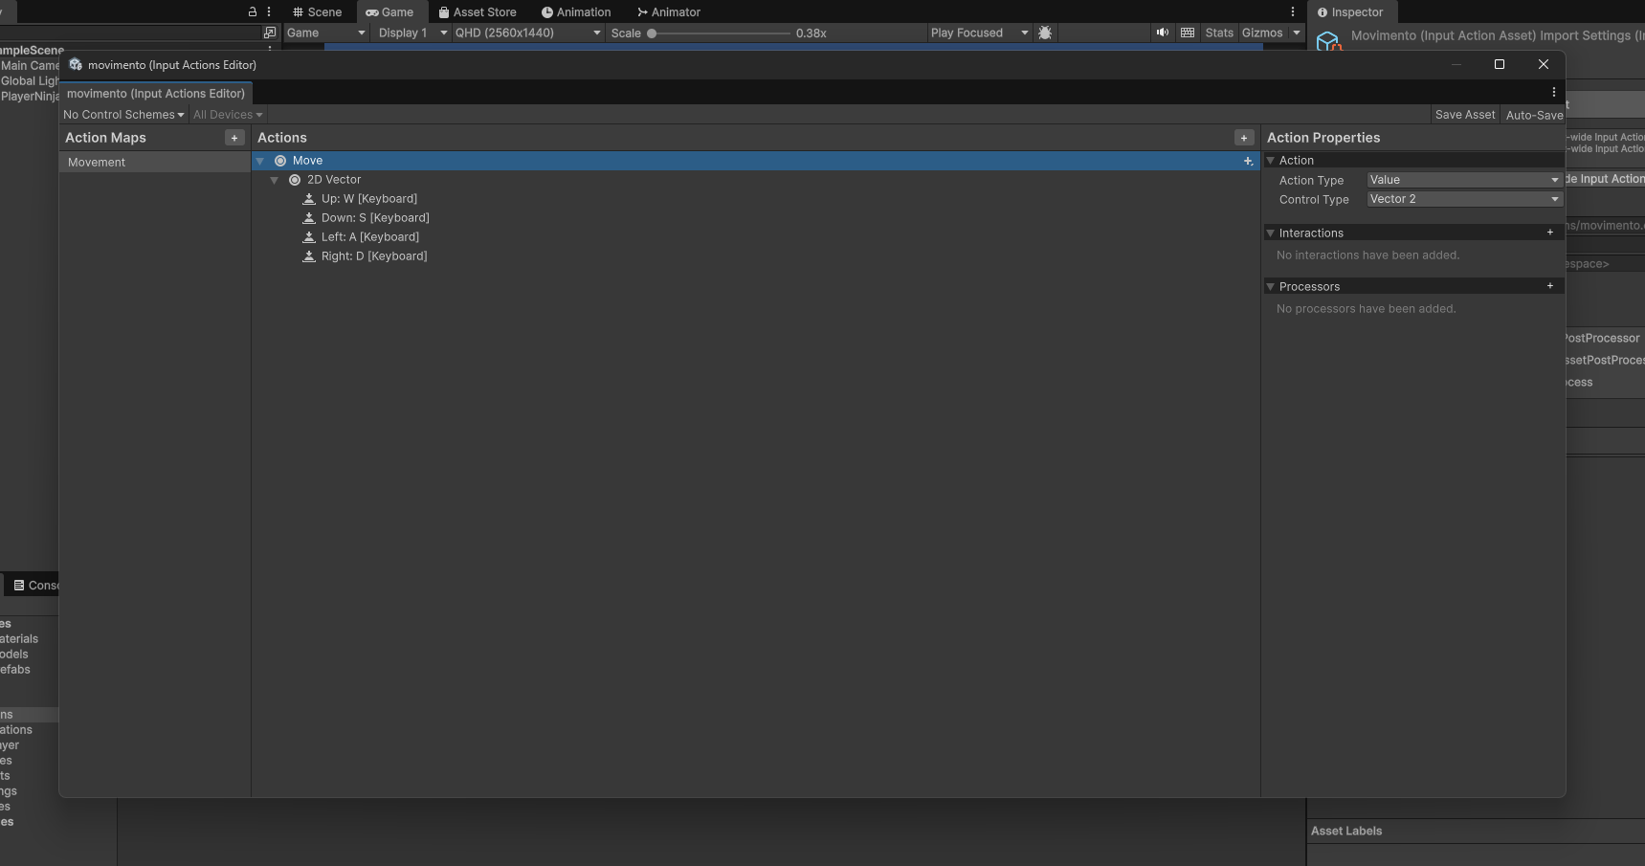

In Level 2, in the Green Ninja character sprites, we adjusted properties such as PPU(Pixels per Unit) for the character to have the correct size within the scene. We used the Sprite Editor to slice the sprite sheets into individual frames in order to create the character’s movement animations as they walk through the scene.

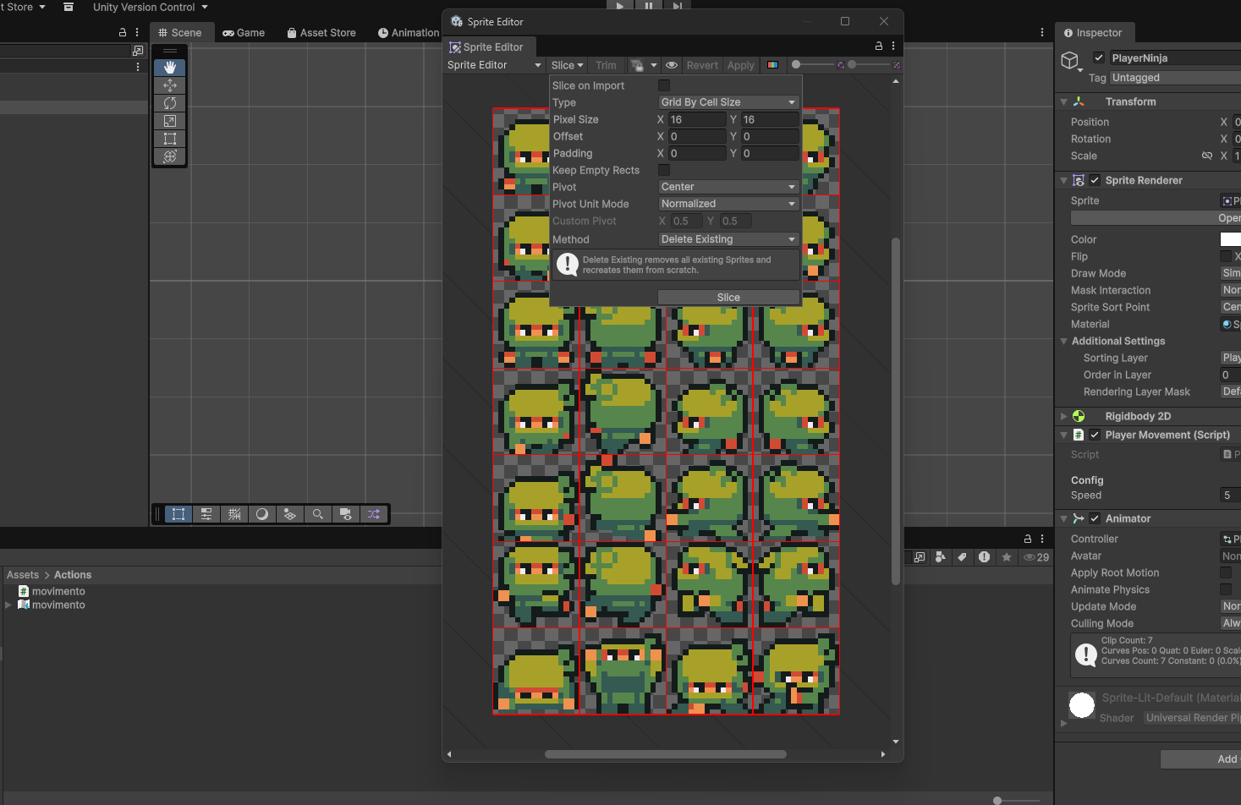

In Level 3, we renamed the main sprite to PlayerNinja and created a Sorting Layer to control the rendering of the characters. We organized folders for our project and created the PlayerMovement script, linking it to PlayerNinja Sprite.
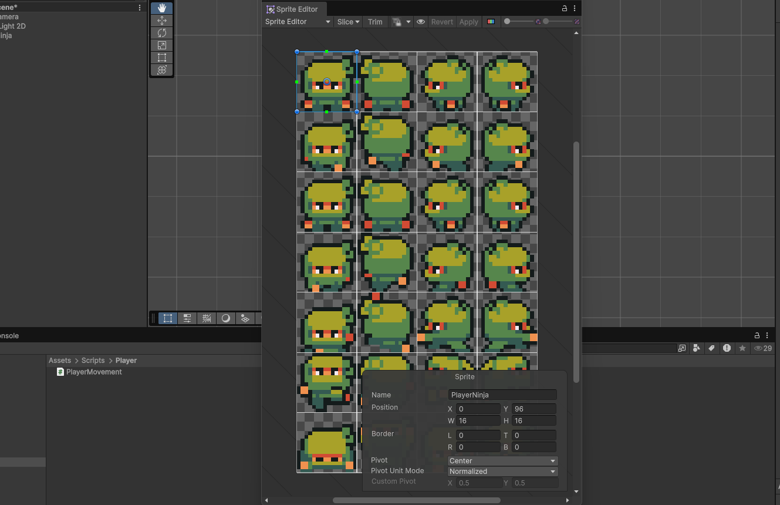

In Level 4, within the script, we defined variables such as the character speed and the Input Actions system, writing methods to enable and disable the commands. This allows us to read keyboard input and set up the character’s movement based on the key pressed.
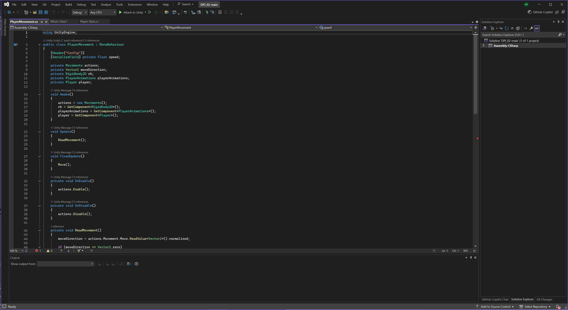

In Level 5 we added a component “RigidBody2D” to “PlayerNinja” so we can move forward, blocking the rotate point, so the character can always stick to correct position. After we make some animations for different actions (move forward, move right, move down, move left), placing all in Animations folders for organization. We use the animater to configurate the “Blend Tree”, which allows us to change automatically between the animations and its values.

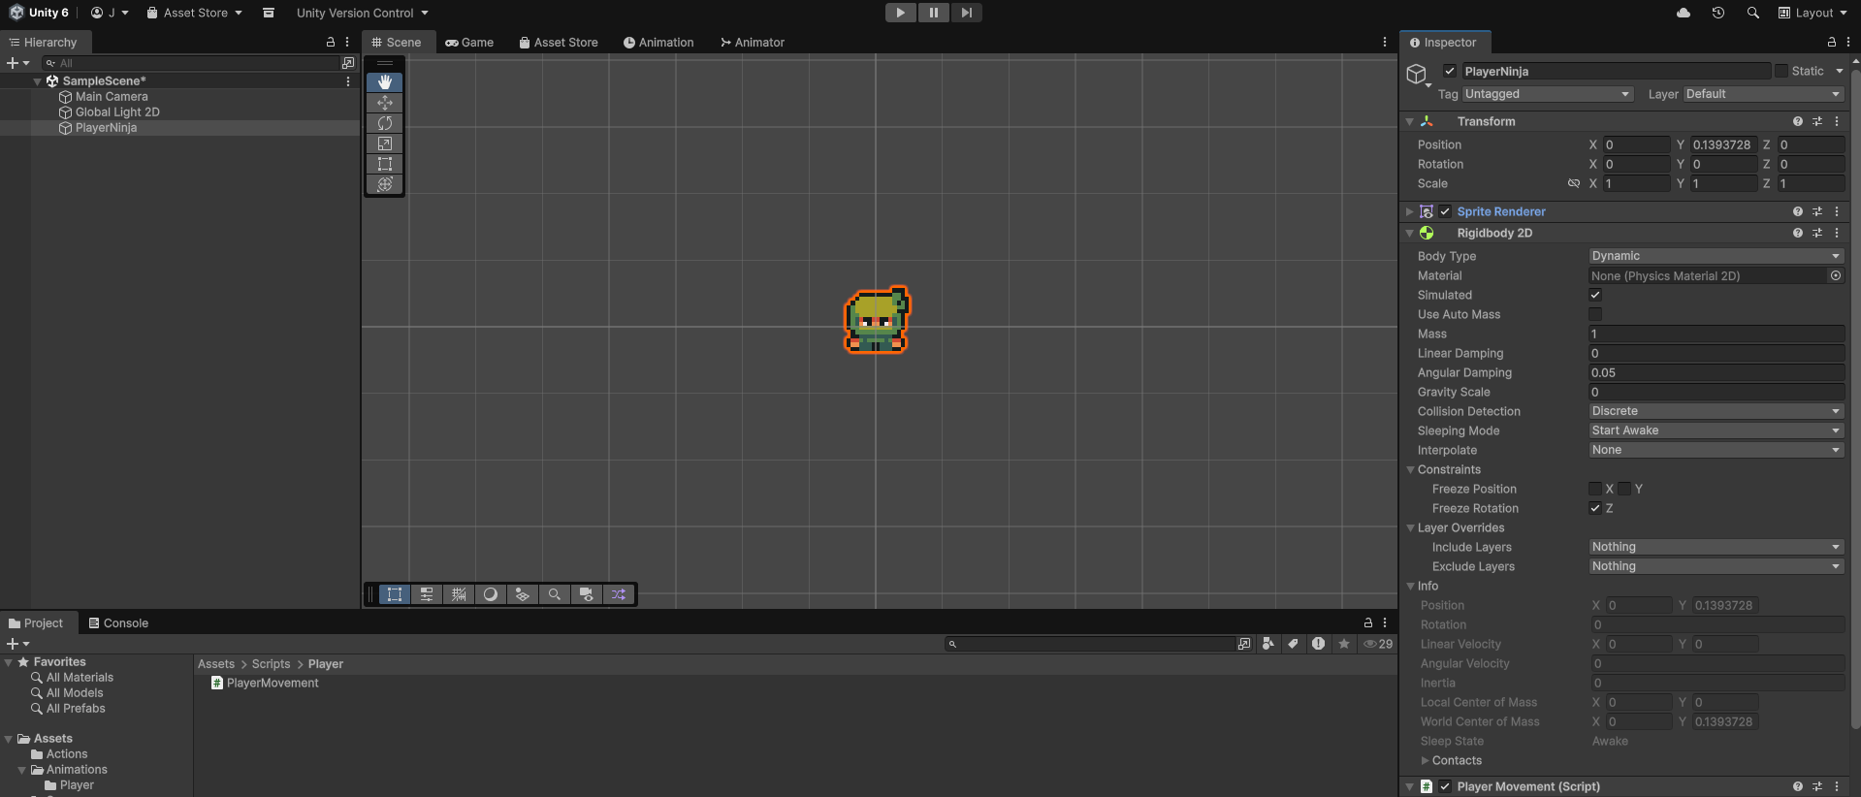 Fig.6
